CS 499 Module One Assignment Template

Complete this template by replacing the bracketed text with the relevant information.

- Self-Introduction: Address all of the following questions to introduce yourself.

  - How long have you been in the Computer Science program?
After earning my CAPM from PMI in December of 2023, I made the decision to continue for my BA in computer science in February or March of 2024.

  - What have you learned while in the program? List three of the most important concepts or skills you have learned.
Important concepts I have learned throughout the program include API connections and testing, data storage and the logic used to create and filter data, transitioning, filtering, and posting important data to a UI, testing throughout the entirety of the full-stack process, and systems architecture, including integration and the full end-to-end process. These concepts have helped me see how the different layers of an application work together. A successful application requires the frontend, backend, APIs, databases, and other systems to communicate correctly and move data through each stage of the process. I have learned how data is created, stored, filtered, transferred, and displayed to the user, as well as how each layer contributes to the functionality of the application.
These concepts have been especially important in connecting what I have learned in the program to my professional career. Learning how systems connect and how data moves through the full end-to-end process has given me a better perspective on how enterprise applications operate. I have also developed a stronger foundation in testing each stage of the full-stack process, including API endpoint testing and testing how data moves between the different layers. The program has helped me see how the different pieces of an application contribute to a successful UI and how each part can be tested, integrated, and improved to create a reliable system.

  - Discuss the specific skills you aim to demonstrate through your enhancements to reach each of the course outcomes.
[I want to demonstrate that I can take an existing artifact, understand how it currently works, identify areas that can be improved, and then make meaningful changes to the application.
Across my three artifacts, I plan to demonstrate skills in software development, algorithms and data structures, database development, testing, security, and working with data from the application layer through the database layer. I also plan to include an AI-related enhancement in the database project to demonstrate how newer technologies can be incorporated into an existing application in a practical way.
I will focus on improving the REST service through additional functionality, input validation, error handling, testing, and security. For the algorithms and data structures artifact, I will improve the existing binary search tree by converting it to an AVL tree and comparing its performance with other approaches. Then, expand the existing MongoDB application and dashboard with aggregation, improved validation, and a limited natural-language query feature.
These enhancements will prove that I can work with an existing codebase, expand upon additional changes to it, and consider how the changes affect functionality, performance, security, and the end user.
]

  - How do the specific skills you will demonstrate align with your career plans related to your degree?
[My current experience is primarily with enterprise resource planning (ERP) systems, cloud infrastructure, and cloud data platforms. This experience has given me exposure to how enterprise applications, infrastructure, and data platforms work together to support business processes and data flow.
The skills I plan to demonstrate through my portfolio align with that experience because enterprise systems depend on applications being able to communicate with databases, move data between systems, and provide that data to users.
The Artemis Financial artifact has the tools to help me demonstrate the application and API side of those connections. The algorithms project allows me to demonstrate how data structures affect the performance of applications that work with larger amounts of data. The Animal Shelter project connects most directly to my database experience and gives me an opportunity to demonstrate how data can be stored, queried, processed, and presented to a user.
I also want to showcase my developing AI skills. AI is becoming increasingly relevant to how data is accessed and processed, so I want to demonstrate that I can incorporate it into an existing application while still considering reliability, security, and how much information is shared with an external service.

]

  - How does this contribute to the specialization you are targeting for your career?
[I am interested in continuing to work with ERP systems, cloud infrastructure, and cloud data storage. My goal is to build on the enterprise technology experience I already have rather than move completely away from it.
The skills I plan to showcase in my ePortfolio support that direction because ERP and cloud environments require applications, databases, APIs, data storage, and infrastructure to work together. I want my portfolio to show that I understand those connections and can work with the technical side of those systems.
The three projects also give me an opportunity to show different parts of that work. The REST service represents the application and integration side, the algorithms project represents how data is processed and accessed efficiently, and the database project represents data storage, analysis, and the user-facing side of working with data.]

- ePortfolio Set Up:

  - Submit a screen capture of your ePortfolio GitHub Pages home page that clearly shows your URL.
[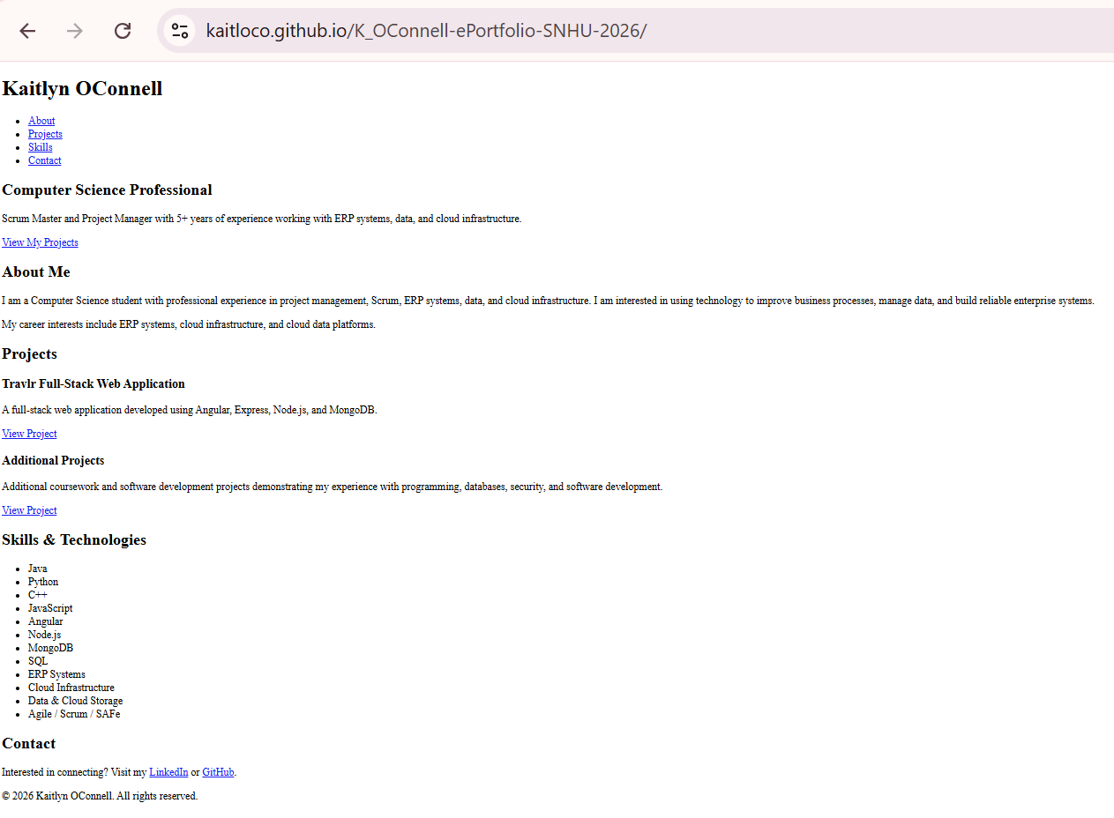

- Enhancement Plan:

  - Category One: Software Engineering and Design
    - Select an artifact that is aligned with the software engineering and design category and explain its origin. Submit a file containing the code for the artifact you choose with your enhancement plan.

[I have chosen my Artemis Financial artifact from CS-305. The project was a Java Spring Boot REST service that I developed as part of the course.
I selected this as an artifact because it already has a backend application structure and REST endpoints that can be expanded. It gives me an opportunity to improve the way the application handles security, errors, validation, and testing while also adding new functionality. The project also allows me to demonstrate how an API can receive information, process it through the application, and return information to the user
]

    - Describe a practical, well-illustrated plan for enhancement in alignment with the category, including a pseudocode or flowchart that illustrates the planned enhancement.

[For this enhancement, I plan to expand the existing REST service rather than only fixing issues in the original project. I will add a new /validate-transaction endpoint that accepts a transaction request, validates it against defined business rules, and returns a structured response indicating whether the transaction was accepted or rejected.
I will also improve the existing application by using Spring's validation capabilities, adding centralized error handling, and expanding the automated tests. The application will return consistent error messages without exposing internal application details. I will also carry forward the security work from the original project, including secure communication and avoiding sensitive information in application logs.
Pseudocode:
Start

Get User Prompt

Validate request

If prompt is invalid
Return error
Else
Send prompt to application logic

Process request

If an error occurs
Handle error
Return appropriate response
Else
Return successful response
End If
End If

Run tests

Review security and data handling

End
]

    - Explain how the planned enhancement will demonstrate specific skills and align with course outcomes.

      - Identify and describe the specific skills you will demonstrate that align with the course outcome.

[The skills I plan to demonstrate surround adequate testing of APIs, working with a Java Spring Boot application, developing and modifying REST APIs, separating application responsibilities, validating user input, handling application errors, writing and running tests, reviewing an existing application to identify areas for improvement, applying secure coding practices, and documenting technical changes. This will demonstrate my ability to take an existing application and make larger improvements to its design, functionality, and reliability.

      - Select one or more of the course outcomes below that your enhancement will align with.

[The project aligns with Outcomes 2, 3, 4, and 5. Outcome 2 applies due to the API changes, explaining how the new functionality works, and communicating the design decisions through my code review and narrative. Outcome 3 applies because decisions about how the application should validate requests, handle errors, and separate responsibilities between the different parts of the application will be showcased. Outcome 4 applies because I will be using Java, Spring Boot, REST APIs, and automated testing to expand an existing application. Outcome 5 applies because the changes will include input validation, secure communication, appropriate error handling, and prevent sensitive application information from being exposed.]

  - Category Two: Algorithms and Data Structures

- Select an artifact that is aligned with the algorithms and data structures category and explain its origin. Submit a file containing the code for the artifact you choose with your enhancement plan. You may choose work from the courses listed under Category One.

[ I have chosen my Binary Search Tree project from CS-300. The project was developed in C++ using the eBid Monthly Sales dataset.
The original project uses a binary search tree to store and search bid information. I selected this project because it provides a good opportunity to demonstrate how the choice of a data structure affects application performance. It also gives me the opportunity to take an existing implementation and make a significant change to how it manages the data.]

- Describe a practical, well-illustrated plan for enhancement in alignment with the category, including a pseudocode or flowchart that illustrates the planned enhancement.

[For this enhancement, I plan to convert the existing binary search tree into a self-balancing AVL tree.
The main purpose of this change is to improve the consistency of search performance as the amount and order of the data changes. An unbalanced binary search tree can become inefficient when data is inserted in a particular order. An AVL tree addresses this by maintaining a balance between the left and right sides of the tree as new records are added.
I will implement the necessary left, right, left-right, and right-left rotations and add tests to verify that the tree remains balanced after insertions.
I also plan to compare the performance of the original binary search tree, the enhanced AVL tree, and a hash table using the same dataset. I will test the structures using the original dataset and larger versions of the dataset so I can compare how their performance changes as the amount of data increases.
Pseudocode:
Start

Load dataset

Insert records into AVL tree
Rebalance tree after each insertion

Measure insertion time

Search for selected records
Measure search time

Repeat using original BST

Repeat using hash table

Compare results at different dataset sizes

Compare actual results with theoretical Big-O

End
]

- Explain how the planned enhancement will demonstrate specific skills and align with course outcomes.

  - Identify and describe the specific skills you will demonstrate to align with the course outcome.

[The skills I plan to demonstrate include C++ development, implementing an AVL tree, understanding tree rotations, analyzing algorithmic complexity, using Big-O notation, benchmarking application performance, and comparing different data structures.
I also want to demonstrate that I understand the trade-offs involved in choosing a data structure. The goal is to show an understanding of why the AVL tree performs differently from an unbalanced tree and how that compares with a hash table.
]

  - Select one or more of the course outcomes listed under Category One that your enhancement will align with.

[Outcomes 2, 3 and 4, will be presented. Outcome 3 applies because I will be using different tree structures to organize and sort data and then evaluating how those structures perform when working with the same dataset. I will be able to explain the differences between the original binary search tree and the AVL tree and why the additional balancing logic can be useful. Outcome 4 applies because I will use C++, data structures, and algorithms to improve an existing enhancement. Outcome 2 also applies because I will document the differences and communicate the results of the testing and comparisons.]

  - Category Three: Databases

    - Select an artifact that is aligned with the databases category and explain its origin. Submit a file containing the code for the artifact you choose with your enhancement plan. You may choose work from the courses listed under Category One.

[I have chosen my Animal Shelter CRUD artifact from CS-340. The project was developed in Python and MongoDB and uses an animal shelter dataset to perform create, read, update, and delete operations. The project also includes a dashboard for interacting with and analyzing the data.
This project has the strongest connection between my academic work and my professional experience with data systems. I already work with cloud data storage and technologies such as DynamoDB and Redshift, so this project gives me an opportunity to demonstrate database development skills while also connecting the project to the type of work I do professionally.
]

    - Describe a practical, well-illustrated plan for enhancement in alignment with the category, including a pseudocode or flowchart that illustrates the planned enhancement.

[For this enhancement, I plan to expand the existing MongoDB application and dashboard.
I will improve the CRUD layer by adding data validation and structured error handling. This will help prevent invalid data from being written to the database and will provide more useful responses when an operation fails.
I will expand the dashboard to use MongoDB aggregation pipelines for filtering and summarizing the data. This will move more of the data processing into the database rather than pulling large amounts of raw data into the dashboard before processing it.
Psuedocode:
Start

Connect to MongoDB

Receive user request

If request is a natural-language question
Identify the intended query
Map request to approved aggregation pattern
Execute aggregation
Generate short summary
Else
Validate request
Execute CRUD or aggregation operation
End If

If database error occurs
Handle error
Return safe error message
Else
Format and display results
End If

Run database and validation tests

Review query efficiency and data exposure

Document changes

End
The dashboard and database layer will also be separated so that the user interface does not contain direct database logic. This will make the project easier to maintain and better demonstrate how the different parts of an application work together.]

    - Explain how the planned enhancement will demonstrate specific skills and align with course outcomes.

      - Identify and describe the specific skills you will demonstrate that align with the course outcome.

[I can perform many skills related to Python development, MongoDB CRUD operations, aggregation pipelines, data validation, error handling, dashboard development, and connecting database functionality to a user interface.
MongoDB, DynamoDB, and relational databases have different strengths and use cases, and understanding those differences is important when designing data solutions.]

      - Select one or more of the course outcomes listed under Category One that your enhancement will align with.

[This enhancement aligns with Outcomes 2, 3, 4, and 5 because it combines database development, application design, user interaction, and security considerations. Outcome 3 applies because I will be evaluating how data should be retrieved and processed through MongoDB aggregation rather than moving all of the processing to the dashboard. Outcome 4 applies because I will use Python, MongoDB, aggregation pipelines, and AI to expand an existing application. Outcome 5 applies because I will use data validation, controlled access to information, safe error handling, and limitations on what data is provided to the AI component. Outcome 2 also applies because the dashboard and documentation will need to present the information in a way that is understandable to the end user.]

- ePortfolio Overall Skill Set

  - Accurately describe the skill set to be illustrated by the ePortfolio overall.
    - Skills and outcomes planned to be illustrated in the code review

[The skill sets I plan to showcase include moving data through all three layers of an application, sorting and organizing data, and making sure the user interface is simple enough for an end user to navigate. I want the code review to show how data starts with the user, moves through the application and database layers, and then comes back to the user in a way that makes sense. The three artifact upgrades give me different ways to demonstrate my skills, from the REST service and API layer, to sorting and organizing data, to storing, processing, and displaying data through a user interface.

I also want to demonstrate that I understand what happens between each step. The data needs to be validated, the application needs to handle errors, and the information returned to the user needs to be accurate and understandable. The code review will give me an opportunity to walk through the original artifacts, and explain my understanding of the changes and why they were made.

    - Skills and outcomes planned to be illustrated in the narratives

[The narratives will explain what I learned from each artifact and how the enhancements connect to my professional experience. I want the narratives to show that my skills enhanced beyond just coding. I have learned how different systems connect, how data moves between them, how different data structures can be used to organize information, and how databases can be used to store and retrieve data for an end user.
The narratives will also give me an opportunity to explain the decisions I made during the enhancements, the problems I encountered, and how I addressed them. I will connect the projects to the work I have already done with enterprise systems, cloud infrastructure, and data storage. This will help show how the Computer Science program has added to the experience I already had and helped me better understand the development and application side of the systems I work with professionally.

    - Skills and outcomes planned to be illustrated in the professional self-assessment

[The professional self-assessment will bring the different parts of my program together and explain how they enhanced my performance within my current career. Throughout the program, I have developed a better understanding of how applications, databases, data structures, APIs, and infrastructure work together. My professional experience has given me exposure to many of these areas from an enterprise and infrastructure perspective, while the Computer Science program has given me more hands-on experience with the development side.
I want the self-assessment to show that combination and how it supports my transition into the professional world. I have experience working with enterprise cloud infrastructure, ERP systems, and data storage, and I have used the Computer Science program to strengthen my understanding of what happens within the applications and systems that use that infrastructure. The three artifacts support my long-term goals by showing the application and API side, how data can be organized and sorted, and how data can be stored, processed, and presented to a user.

